Rizal Technological University

College of Engineering, Architecture and Technology

**Activity 1**Linkedlist Implementation in C++

Subject **:** Data Stucture And Algorithm

Name **:** Art Lisboa

Instructor **: Engr. Ezekiel Nequit**

Date Submitted **: September 7 2020**

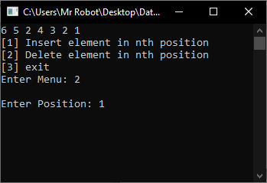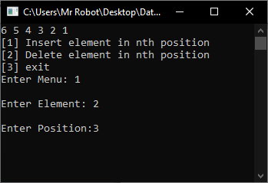

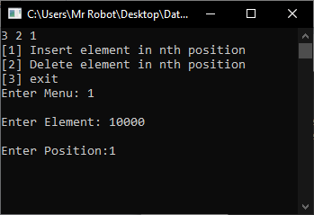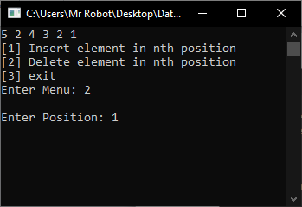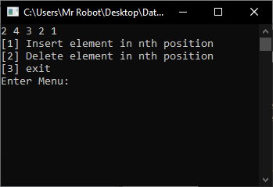

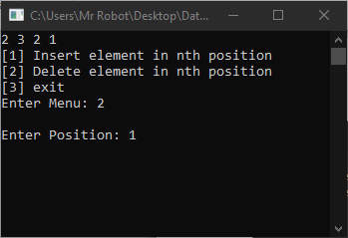

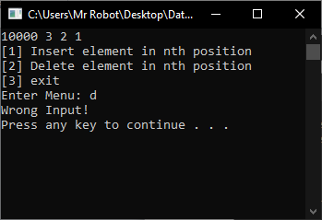

**Source code:**

#include <iostream>

#include<String>

using namespace std;

///CLASS LINKLIST

class linklist{

public:

struct Node {

int data;

struct Node *next;

};

struct Node* head = NULL; //node

void insert(int new_data, int n) {

Node* new_node = new Node;

new_node->data = new_data;

new_node->next = NULL;

//head = new_node;

if (n == 1)

{

new_node->next = head;

head = new_node;

return;

}

Node *temp = head;

for (int i = 0; i < n - 2; i++)

{

temp = temp->next;

}

new_node->next = temp->next;

temp->next = new_node;

}

void display() {

struct Node* ptr;

ptr = head;

while (ptr != NULL) {

cout << ptr->data << " ";

ptr = ptr->next;

}

}

void Delete(int n)

{

struct Node* temp1 = head;

if (n == 1)

{

head = temp1->next;

delete(temp1);

return;

}

for (int i = 0; i < n - 2; i++){

temp1 = temp1->next;

}

struct Node* temp2 = temp1->next;

temp1->next = temp2->next;

delete(temp2);

}

};

////CLASS TAKBO INHERIT FROM LINKLIST

class takbo :public linklist{

public:

void insrt_elmnt(){

try{

int frst_elmnt, scnd_elmnt;

cout << "\nEnter Element: ";

cin >> frst_elmnt;

cout << "\nEnter Position:";

cin >> scnd_elmnt;

insert(frst_elmnt, scnd_elmnt);

run();

}

catch (exception e){

cout << "Number Lang kapatid";

system("pause");

return insrt_elmnt();

}

}

void dlt_elmnt()

{

try{

int dlt_pare;

cout << "\nEnter Position: ";

cin >> dlt_pare;

Delete(dlt_pare);

run();

}

catch (exception e){

cout << "Number Lang kapatid";

system("pause");

return insrt_elmnt();

}

}

void run()

{

string chces;

system("cls");

display();

cout << "\n[1] Insert element in nth position\n";

cout << "[2] Delete element in nth position\n";

cout << "[3] exit\n";

cout << "Enter Menu: ";

cin >> chces;

if (chces == "1")

{

insrt_elmnt();

}

else if (chces == "2"){

dlt_elmnt();

}

else if (chces == "3")

{

system("exit");

}

else{

cout << "Wrong Input!" << endl;

system("pause");

system("cls");

return run();

}

}

void insertdisp(){

insert(1, 1);

insert(2, 1);

insert(3, 1);

insert(4, 1);

insert(5, 1);

insert(6, 1);

}

};

///main function

int main() {

takbo tak;

tak.insertdisp();

tak.run();

}